Your Sample System’s Title: A New System for the Problem of …..

Me and my last name, my Team Mates’ names, Stefan Bund

[MyEmail@cpp.edu](mailto:MyEmail@cpp.edu), [myTeamMatesEmail@cpp.edu](mailto:myTeamMatesEmail@cpp.edu)

Abstract

The problem with the world is…

Contents

Introduction 1

Applying a Venn Analysis 1

Applying a Value Stream and Kanban Analysis 1

Applying an Organizational Hierarchy Study 1

Discovering Discrete Data Flows within the Sociotechnical System 1

## Introduction

Our studies on the problem of ________________ conclude that

1. High level observation one
2. High level observation 2
3. High level observation 3
4. High level observation 4
5. High level observation 5

We will present five analyses which support these observations in this paper, with a proposal to study a system with a potential design.

## Studying the Global Domain of Information

In order to map the global domain of data belonging to each intersecting thing in our business problem, we devised a Venn diagram containing elements related to ……

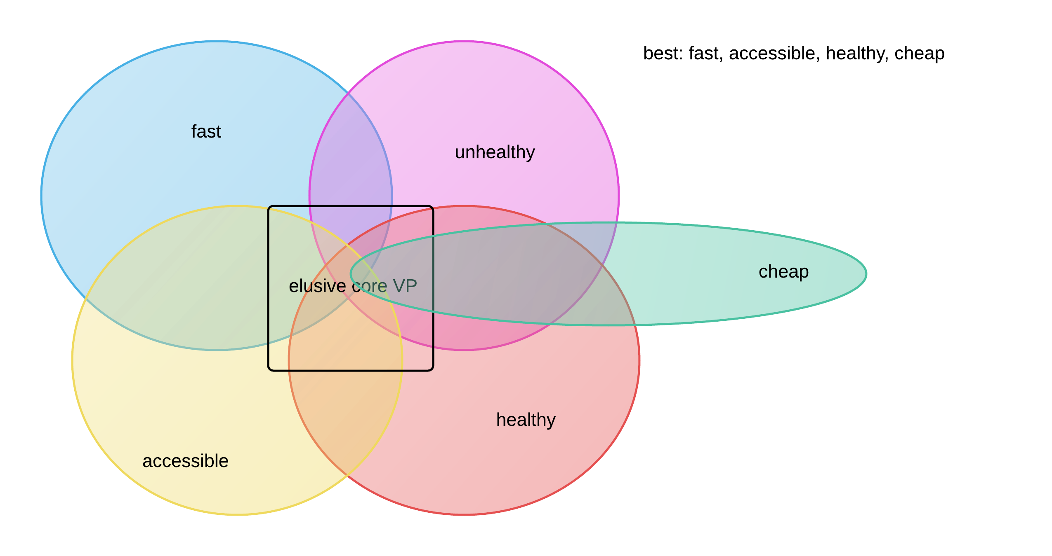

This Venn Analysis yields several observations:

1.

2.

3.

From this we conclude that the global domain of information related to this problem contains this issue:

## Applying a Value Stream and Kanban Analysis

In order to refine our focus on the problem domain of _____________ we devise a value stream to map the sequence of activities leading up to our current situation. We include all details related to ________ as a process, where efficiency and potential loss or waste is measurable.

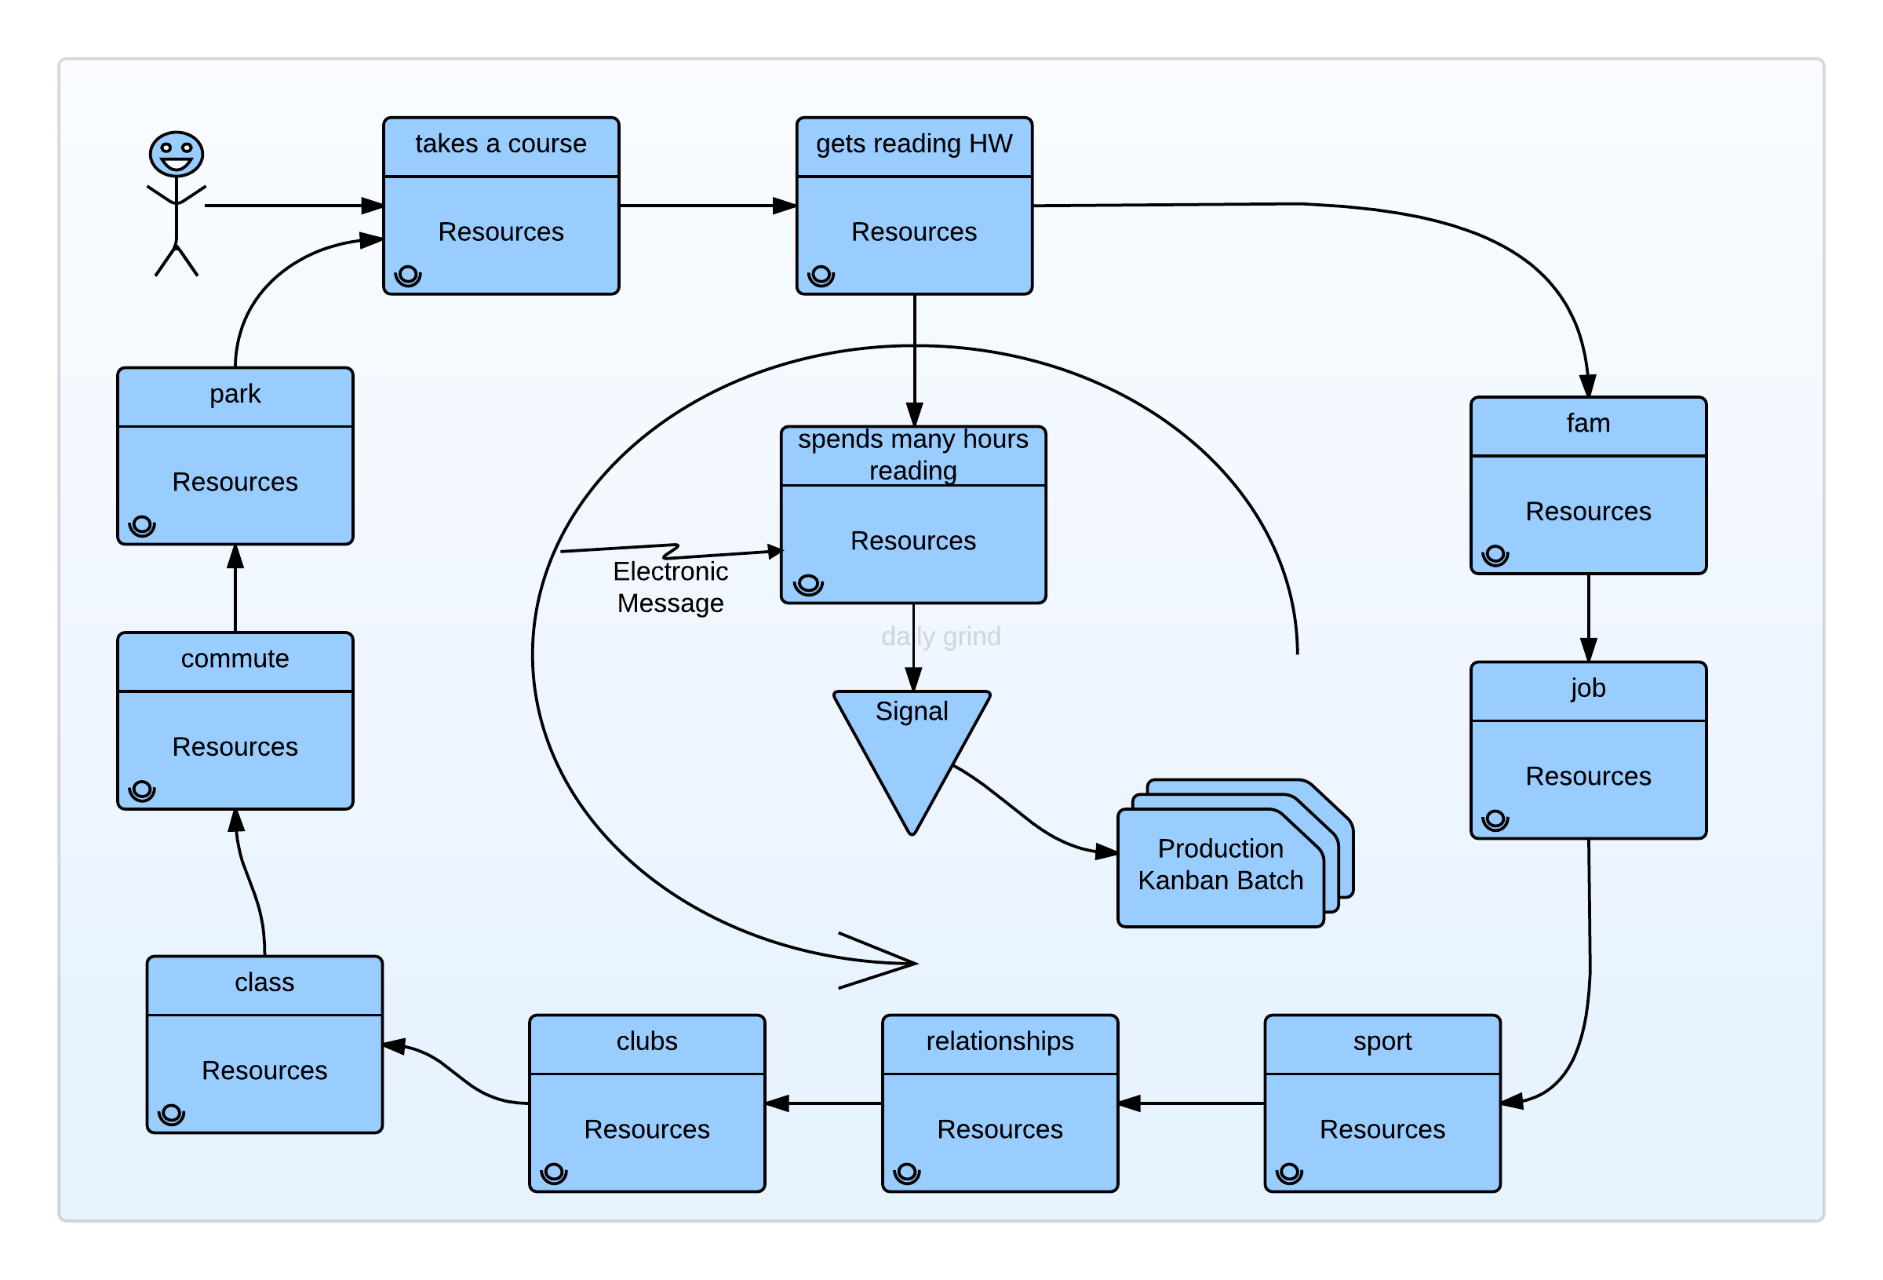

Viewing the entirety of processes related to ________ we identify the following inefficient, or high-friction segments:

1.

2.

3.

We thus conclude that the existing sociotechnical system in our problem domain creates waste while performing _____________, and creates loss when ________________

## Applying an Organizational Hierarchy Study

DIAGRAM + DISCUSSION

## Discovering Discrete Data Flows within the Sociotechnical System

DIAGRAM + DISCUSSION

## Conclusion

Our studies on the problem of ________________ conclude that

1. High level observation one
2. High level observation 2
3. High level observation 3
4. High level observation 4
5. High level observation 5

We will present five analyses which support these observations in this paper, with a proposal to study a system with a potential design.